* MEMBER NAME : W01
  1. General Information
     1. Design Code : IS456:2000
     2. Unit System : N, mm
  2. Material
     1. : 25.00MPa
     2. : 415MPa
     3. : 415MPa
  3. Section
     1. Thickness : 300mm
     2. Length : 3.000m
     3. Cover : 50.00mm
     4. Height(X) : 3.500m
     5. Height(Y) : 3.500m
     6. : 1.000
     7. : 1.000
     8. Frame Type : Braced Frame



* 1. Force
     1. Axial & Moment
        + : 10,000kN
        + : 500kN·m
        + : 100.00kN·m
     2. Shear
        + : 0kN
        + : 0kN·m
        + : 62.00kN
  2. Rebar
     1. Vertical Bar : P3@450
     2. Horizontal Bar : P10@250
     3. Boundary Element Bar : P10@100
  3. Seismic Design Parameters : IS13920:2016
  4. Check Slenderness Ratio

Calculate slenderness ratio **[IS456:2000 25.1.2]**

L/b <= 60 → O.K

* + - * 03.50 > 12 → Not Slender
      * 23.33 > 12 → Slender
  1. Additional Moments and Reduction Factor
     1. Calculation of Reduction Factor **[IS456:2000 39.7.1.1]**

* + 1. Calculate Additional moment (Direction X) **[IS456:2000 39.7]**
       - 5.208333 kN·m
    2. Calculate Additional moment (Direction Y) **[IS456:2000 39.7]**
       - 5.208333 kN·m
  1. Check Minimum Moment
     1. Calculate minimum eccentricity **[IS456:2000 24.4]**
        + 105mm

= 105 mm

* + - * 24.00mm
      * = 24 mm
    1. Calculate minimum moment
       - 1050kN·m
       - 240kN·m
  1. Check Design Moment
     1. Calculate design moment
        + 500kN·m
        + 2157kN·m
        + 317kN·m
  2. Check Design Parameter
     1. Calculate rebar ratio
        + 900,000mm² 1,135mm²
        + 0.00126
     2. Calculate concentric axial load capacity
        + 18,791kN
        + -454kN
  3. Check Balanced Moment Capacity of Direction X ( Balanced axis )
     1. Calculate capacity of compression stress block
        + 1,748mm
        + 9,092kN
        + 6,884kN·m
     2. Calculate capacity of rebar

|  |  |  |  |  |  |  |
| --- | --- | --- | --- | --- | --- | --- |
| **i** | **TYPE** | **(mm)** |  | **(MPa)** | **(mm²)** | **(kN)** |
| 1 | Ver. | 87.02 | -0.002000 | -400 | 142 | -56.77 |
| 2 | Ver. | 537 | -0.001228 | -246 | 142 | -34.85 |
| 3 | Ver. | 987 | -0.000455 | -91.04 | 142 | -12.92 |
| 4 | Ver. | 1,437 | 0.000317 | 63.44 | 142 | 9.005 |
| 5 | Ver. | 2,913 | 0.002851 | 400 | 142 | 56.77 |
| 6 | Ver. | 2,463 | 0.002078 | 400 | 142 | 56.77 |
| 7 | Ver. | 2,013 | 0.001306 | 261 | 142 | 37.07 |
| 8 | Ver. | 1,563 | 0.000533 | 107 | 142 | 15.14 |

70.22kN

275kN·m

* + 1. Calculate nominal capacity for balanced axis

9,162kN

7,159kN·m

* 1. Check Moment Capacity of Direction X ( Neutral axis )
     1. Calculate capacity of concrete stress block

x = 3,424mm

17,811kN

799kN·m

* + 1. Calculate capacity of rebar

338kN

105kN·m

18,148kN

905kN·m

* + 1. Calculate axial load and moment capacities

9,771kN

588kN·m

1.023 > 1.000 → N.G

0.850 < 1.000 → O.K

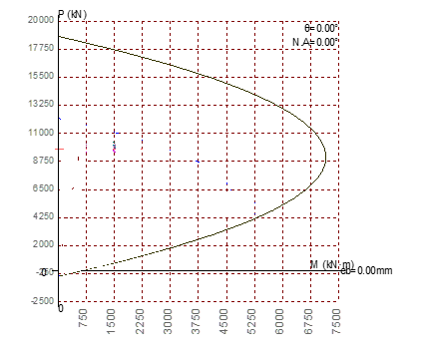

* 1. Check Balanced Moment Capacity of Direction Y ( Balanced axis )
     1. Calculate capacity of compression stress block

128mm

6,648kN

636kN·m

* + 1. Calculate capacity of rebar

|  |  |  |  |  |  |  |
| --- | --- | --- | --- | --- | --- | --- |
| **i** | **TYPE** | **(mm)** |  | **(MPa)** | **(mm²)** | **(kN)** |
| 1 | Ver. | 87.02 | -0.002000 | -400 | 568 | -227 |
| 2 | Ver. | 213 | 0.000957 | 191 | 568 | 109 |

-118kN

21.15kN·m

* + 1. Calculate nominal capacity for balanced axis

6,529kN

657kN·m

* 1. Check Moment Capacity of Direction Y ( Neutral axis )
     1. Calculate capacity of concrete stress block

x = 24.97mm

1,299kN

* + - * 181kN·m
    1. Calculate capacity of rebar

-454kN

0.000kN·m

845kN

181kN·m

* + 1. Calculate axial load and moment capacities

760kN

163kN·m

13.15 > 1.000 → N.G

13.24 > 1.000 → N.G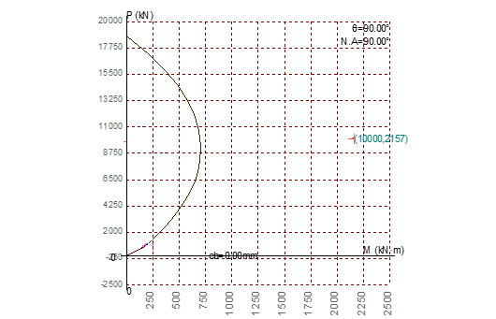

* 1. Check Shear Capacity
     1. Calculate maximum shear strength

2,400mm

2,928kN ***[*[IS456:2000 *Table 20 ]***

2,196kN

→ O.K

* + 1. Calculate shear strength (Direction X)

Detla = 1 + 3 Pu / Ag fck **[IS456:2000 40.2.2]**

Tc = Tc x Delta

* + - * 802kN **[ IS456:2000 T table 19]**
      * 1,394kN **[IS456:2000 2000 40.4 c]**
      * 2,196kN

0.0282 → O.K

* 1. Check Rebar
     1. Calculate rebar ratio

Hw/Lw > 2 [**IS13920:2016 10.1.5]**

0.00250 0.00126

0.00250 + 0.5 0.02185

→ N.G

→ O.K

* + 1. Calculate rebar spacing **[IS13920:2016 10.1.9]**

Min(1/5*Lw,3tw,450) 450mm

Min(1/5*Lw,3tw,450) 250mm

→ N.G

→ O.K

* 1. Check Boundary Element
     1. Check Boundary Condition required [**IS13920:2016 *10.4.1]***

flimit = 0.2 fck = 5 N/mm2

fc = = and -6.45 N/mm2

→ Provide Boundary Element

* + 1. Check Boundary Condition required

fL = 0.15 fck = 3.75 N/mm2

* + 1. Calculate maximum spacing of horizontal rebar**[IS13920:2016 *10.4.3]***

→ N.G

* + 1. Calculate horizontal rebar in x-direction **[IS13920:2016 10.4.1]**

Ash = 0.05 sv h fck/fy

* + 1. Calculate horizontal rebar in y-direction **[IS13920:2016 10.4.1]**

Ash = 0.05 sv h fck/fy

* 1. Check Dimension by Special Provision for Seismic Design
     1. Calculate section dimension limit

**[IS13920:2016 10.1.2]**

* + 1. Calculate section dimension ratio
       - **[IS13920:2016 10.1.3]**